A High-Level Business Case for Advancing Business Analysis Capabilities

Executive Summary
Driven by the rise of complexity and uncertainty in today’s world, business analysis is key to enabling change that drives project and business success.
The essence of value in a business context centers around Return on Investment (ROI). ROI is the weight of the business value or benefits, typically captured as increases in revenue or decreases in cost, over the cost of implementation of the change. When thinking about return on investments, business analysis before, during and after the life cycle of the project could mean the difference between a failed initiative and a successful one.

Introduction
The objective of this business case is to quantify the impact of advancing business analysis capabilities through IIBA’s Global Corporate Program. It will focus on direct costs-benefit analysis and determine the return on investment.

Business Need

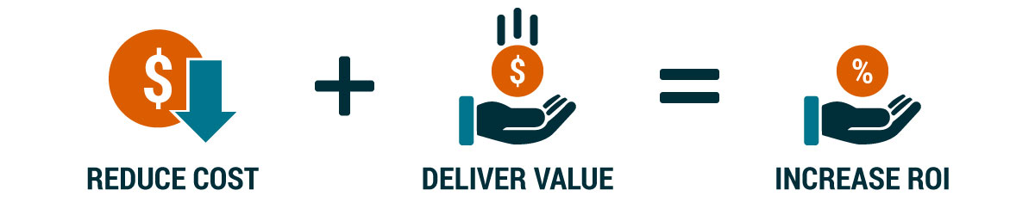
- Avoid Rework  - Cost-Effective Solutions  - Scale Teams | - Discover new opportunities  - Prioritize value  - Meet customer expectations  - Effective change management

Analysis
Business analysis is a formalized, disciplined process for identifying, articulating, and facilitating a change needed to solve a business problem or address a business opportunity.
When it comes to cost, many organizations focus on technology costs and forego other business-related costs such as stakeholder involvement, in determining ROI or the cost of owning the solution throughout its entire product lifecycle.
By developing or advancing business analysis competencies through a commitment to workforce upskilling gain a competitive edge by delivering the right product with accurate and agile analysis at all levels of planning.

Possible Options
IIBA’s Global Corporate Program provides the support and resources organizations need to build business analysis capabilities and drive professional development and growth. It offers Bronze, Silver, Gold, and Platinum-level memberships to meet different organizational needs (see Details Section of this document).

Cost/Benefit Analysis
Example: Silver Level Global Corporate Program Membership
PROGRAM COMPONENTS | Silver Member | Non-Member
Enterprise access to Global Business Analysis Core Standard | a
Corporate Leader Webinars | a
Archived Corporate Leader Webinars a | a
Chapter Engagement | a
Certification Exam Discounts | a
Company Listed on IIBA website | a
Quarterly High-Level Benchmarking Report | a
Tiered Discount Membership and Certification Structure | a
Certification Webinar (recorded) | a
Access to IIBA Corporate Resources | a
Enterprise access to IIBA BABOK® V3 Guide | a
Enterprise access to IIBA Agile V2 Extension | a
Enterprise access to IIBA Guide to Business Data Analytics | a
Eligibility to Corporate Awards | a
PROGRAM COMPONENTS SUBTOTAL | $5000 | $0
PROGRAM BENEFITS
New business needs or requirements are discovered | a
Prioritization ensures focus on value | a
More effective implementation of new solutions by the business | a
Providing a framework in which teams can scale | a
20 Business Analysis Practitioner Memberships | $0 | $2,500
10 CCBA/CBAP Application and Exam | $3,314  (2 included + 8 with corporate discount) | $5,750  (for 10 with no discount)
GRAND TOTAL | $8,314 | $8,250

Example: Business Analysis work for acquisition of software applications
Benefits | Business Analysis $$
Business Analysis work at annual salary of $100,000 | $16,666  (320 hrs over 2 months)
Minimum savings by avoiding costly conversions,  loss of data, and manual workarounds | $100,000 to $200,000
Return on Investment  in the first year for one application | $89,000 to  $189,000

Recommendation
- Build and advance business analysis capabilities with alignment to IIBA standards.
- Accelerate career progression and align professional development with business needs.
- Engage in a community of like-minded leaders.
- Gain exclusive insights and resources.

Details
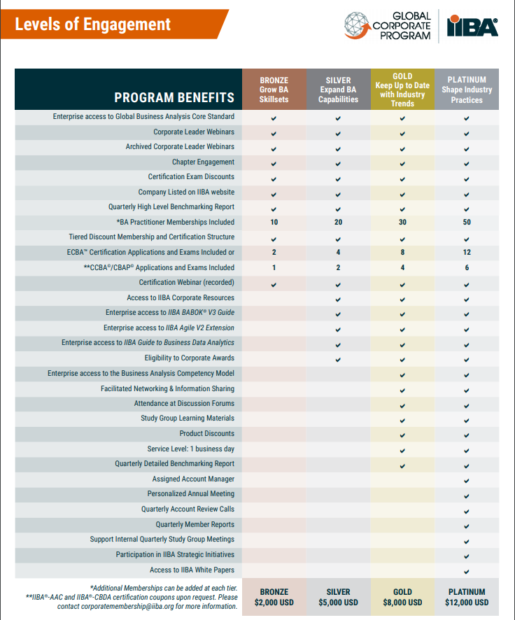

Conclusion
With the standards and resources provided through IIBA’s Global Corporate Program advance business analysis capabilities and empower teams to create business impact.
New business needs or requirements are discovered.
Business analysis is not just picking up or “gathering” the requirements. Business analysis is actively mining for or discovering the requirements. By actively discovering requirements, business analysis helps the business come to an improved understanding of what is needed from the solution to be successful. It provides a direction towards success.
Prioritization ensures focus on value.
Stakeholders are often reluctant to prioritize. By using various prioritization techniques and prioritizing at several stages in the requirements lifecycle a Business Analysis helps ensure that efforts are invested in the requirements with the most potential benefit. It is a guardian of strategic alignment.
More effective implementation of new solutions by the business.
Even without formal change management practices, focusing on business analysis principles of clarity and alignment help the organization prepare for change. It enables the execution of strategies.
Providing a framework in which teams can scale.
As an organization grows, so do the number of stakeholders, projects, and teams. As this happens, the natural patterns of communication that worked for a smaller team tend to fall apart. Business Analysis is a key component in enabling a small team to scale to a larger one, thereby increasing the benefits realized because more projects can be successful investments. It delivers results by increasing efficiencies, clarity of scope and advocating for the customer.

