Running a Customer Journey Workshop Virtually &
Sample Template
  - contributed by Carl Sudholz

Purpose | Create a customer journey map
Length | 2 hours
Participants | Typically, 4-8 people who represent a diverse cross-section  of skills and experience involved in marketing, sales and frontline services.  Likely some combination of:  - Experts in what customers go through in this context, such as a customer support agent, developer,  or user researcher.  - Service owner or the project's full-time owner.  - Individuals on the frontlines of providing the service.  - Individuals on the frontlines of making the product.  Teams that provide an internal-facing service benefit from pulling an internal customer into the session.  Designate a facilitator and scribe for the session.
Prerequisites | - Define the map's scope.  - Ideally, user journey mapping focuses on the experience of a single persona in a single scenario  with a single goal. Else, the journey map will be too generic, and you'll miss opportunities for new insights and questions.  - Once scope is agreed on, check your invite list  to make sure you've people who know the details  of what customers experience when using your  product or service.

Time  (h:mm) | # | Agenda Session | Activity | Resources | Outcome
0:00 | 1 | Welcome | Whole of group chat |  | - Check in.  - Make sure everyone can see and hear.  - Everyone has access to online tools.
0:02 | 2 | Agenda and introduction | Whole of group chat | Workshop agenda. | - Run through on the workshop.  - Confirm everyone has been able  to log into the online tools and are ready to go.
0:05 | 3 | Who is our customer? | Whole of group walk through of the specific customer whose journey you wish to consider. | Customer Profile or persona (developed in previous workshop) | Overview of the customer persona.  It's really important that your group understands the user persona and the goal driving their journey. Decide on or recap with your group the target persona and the scope of the journey being explored in your session.
0:15 | 4 | The Journey Template |  | Journey Template
0:25 | 5 | Attract | - Whole group.  - 3 minutes: Individual working on the board quietly.  - 2 minutes:  of Q&A.  - Repeat. |  | What are the ways customers are attracted?  How are customers seeing it.  Hang out in the places they hang out.  I need in order to .  I need so that .
0:40 | 6 | Engage & Nurture | Break out rooms |  | What is said to the customer?  How do you introduce yourselves, or gain their interest?
0:55 | BREAK

Time  (h:mm) | # | Agenda Session | Activity | Resources | Outcome
1:00 | 7 | Convert | Break out rooms |  | When a customer is ready to buy, how do you know?  What do you do and say?
1:15 | 8 | Service | Break out rooms |  | How do you deliver on promise?  What is the customers’ experience?
1:30 | 9 | Retain | Break out rooms |  | Once the product or service is delivered, how do you build an ongoing relationship?
1:45 | 10 | Summary and Review | Who of group workshop |  | Analyze the big picture. As a group, look at the journey map and discuss trends and patterns in the experience.  - Where are the areas of greatest confusion/frustration?  - Where is the journey falling short  of expectations?  - Are there any new un-met needs that have come up for the user type?  - Are there areas in the process being needlessly complicated or duplicated?  Then discuss areas of opportunity to improve the experience.
2:00 | CLOSE

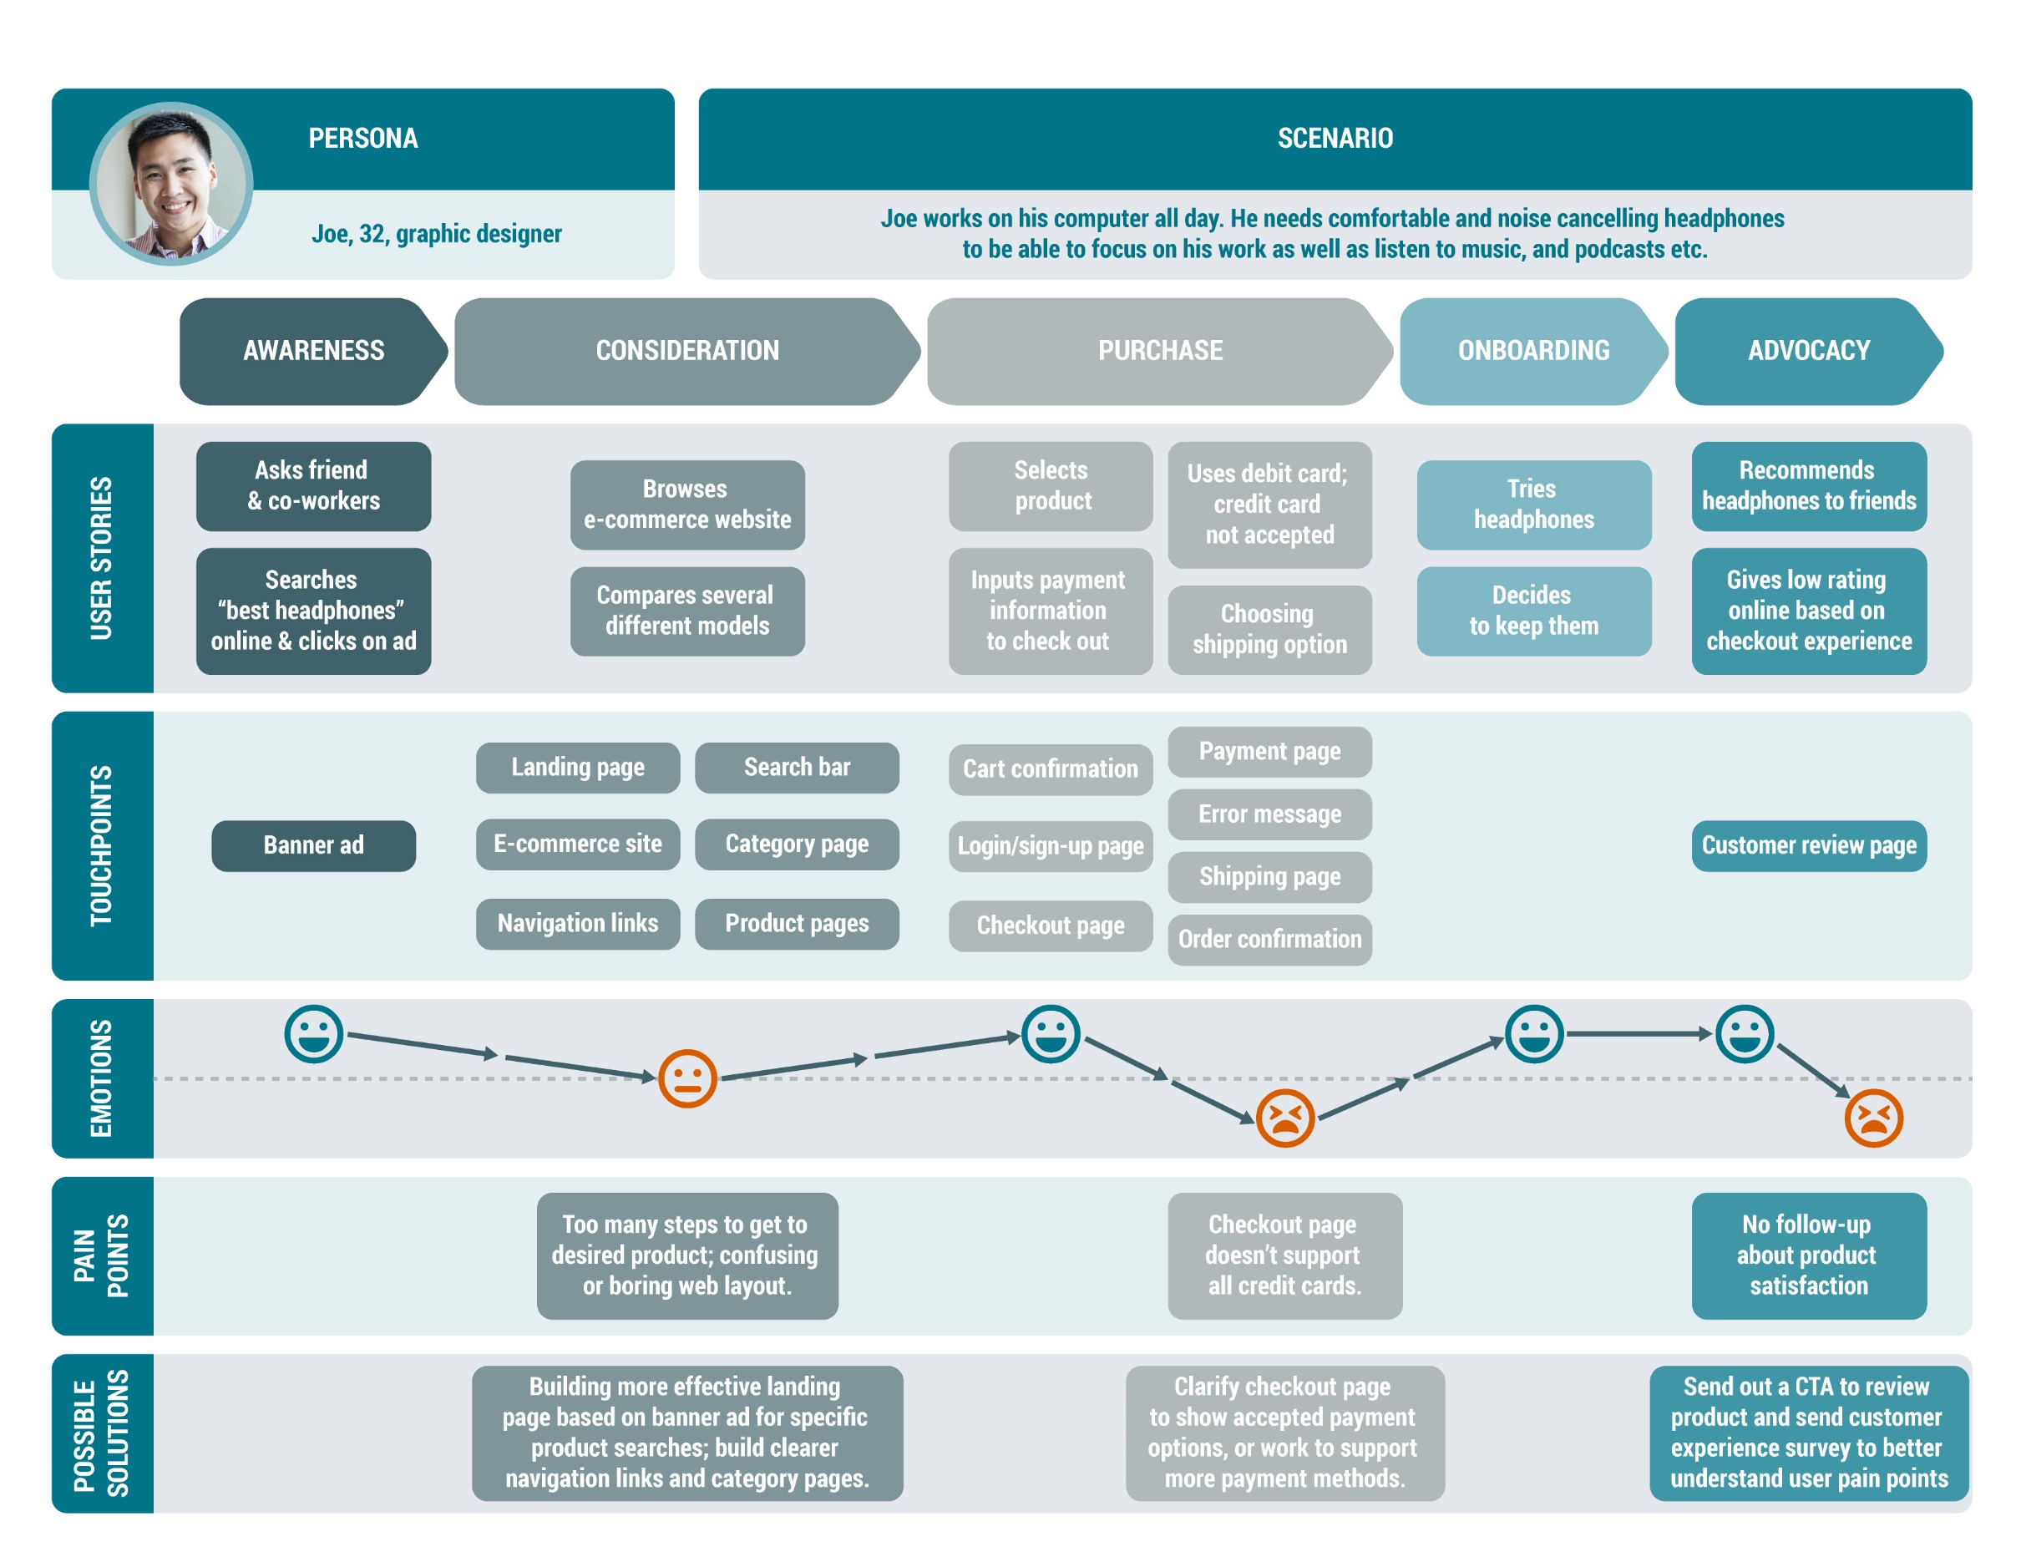
PERSONA | Name and brief summary description of the customer persona  that this journey follows.
 | ATTRACT  Awareness | ENGAGE  Consideration | CONVERT  Purchase | SERVICE  Onboarding | RETAIN  Advocating
ACTIONS
What is this
person doing?
CHALLENGES
What challenges or pain points are they seeking to overcome?
THOUGHTS
What are they
thinking about?
FEELINGS
What are
they feeling?
TOUCHPOINTS
How are they interacting with you? Which channels?
MESSAGES
What messages are you sending them?
IMPROVEMENTS
What improvements can you make to the current state?

References
https://www.retrofuzz.com/blogs/how-to-run-a-customer-journey-mapping-workshop
https://www.lucidchart.com/blog/how-to-build-customer-journey-maps
https://boagworld.com/audio/customer-journey-mapping/
